

**AMERICAN INTERNATIONAL UNIVERSITY–BANGLADESH (AIUB)**

**FACULTY OF SCIENCE & TECHNOLOGY**

**DEPARTMENT OF PHYSICS**

**PHYSICS LAB 1**

**Summer 2020-2021**

**Section: J | Group: 06**

**LAB REPORT ON**

***To determine the time constant of an RC circuit.***

**Supervised By**

**BITHI PAUL**

**Submitted By**

|  |  |  |
| --- | --- | --- |
| **Name** | **ID** | **Contribution** |
| **1. AHMED FARHAN AMIN** | **21-44804-1** |  |
| **2. NOKIBUL ARFIN SIAM** | **21-44793-1** |  |
| **3. M.A.R.M SOURAV** | **20-43647-2** |  |
| **4. G.M ALVI SIDDIQUE** | **20-43659-2** |  |
| **5. SHAYAKH AL ARAF SLOWK** | **21-44591-1** |  |

Submission date ***July 31, 2021***

**TABLE OF CONTENTS**

|  |  |
| --- | --- |
| **TOPICS** | ***Page no*.** |
| 1. **Title Page** | 1 |
| 1. **Table of Content** | 2 |
| 1. **Theory** | 3 |
| 1. **Apparatus** |  |
| 1. **Procedure** |  |
| 1. **Experimental Data** |  |
| 1. **Analysis and Calculation** |  |
| 1. **Result** |  |
| 1. **References** |  |
|  |  |

1. **Theory:**

A capacitor is a device that stores electrical energy in an electric field. It is a passive electronic component with two terminals. The effect of a capacitor is known as capacitance. Capacitors are used in timing circuit in many devices. The time that the dome lights inside a car stay on after turning off the cars ignition at night is one example of how a capacitor can be used to maintain the lighting long enough to remove the key and collect things before exiting. The values we use to characterize these kinds of circuits is given by the time constant defined as: τ = RC, where R is the circuit resistance and C is the capacitance. In this lab, we will observe the charging and discharging of a capacitor and determine the time constant of a RC circuit.

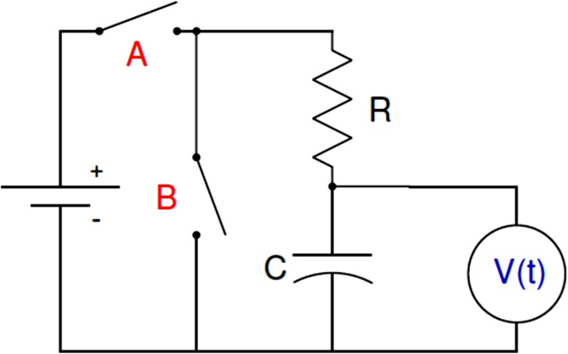

***Figure 6.1:*** *Circuit for RC charge-discharge measurement where V(t) is the potential difference across the capacitor as a function of time.*

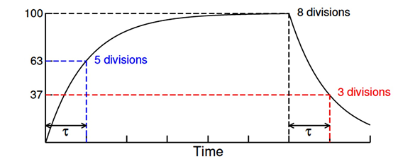

***Figure 6.2:*** *Potential difference across a capacitor in an RC circuit as a function of time.*

*The time constant can be determine by observing the either the charging and discharging process of the capacitor as the Fig. 6.2 shows. For the charging process, τ is the time for V(t) to reach 63% of its final value. For the discharging process, τ is the time for V(t) to fall 63% from its initial value.*

In the RC circuit in fig. 6.1, if at t = 0 switch A is closed (switch B remains open) charges will begin to build up in the capacitor. These charges do not accumulate within the capacitor instantaneously due to the resistance provided by the resistor. The potential difference across the capacitor for this process can be expressed as,

𝑽(𝒕) = 𝑽𝒎 (𝟏 − 𝒆−𝒕/𝝉 ) …………………. (1)

where Vm is the maximum potential difference across the capacitor. After a sufficiently long time

(much larger than time constant), if switch A is open while switch B is closed, the capacitor will

discharge all its accumulated charges. The potential difference across the capacitor can be expressed

as,

𝑽(𝒕) = 𝑽𝒎 𝒆−𝒕/𝝉 ……………………… (2)

For charging, Eq. 1 can be written as,

𝒍𝒏 [𝟏 − 𝑽(𝒕)/ 𝑽𝒎] = (− 𝟏/𝝉) 𝒕 ……………… (3)

Comparing Eq. 3 with y = mx and plotting a graph of "𝒍𝒏 [𝟏 − 𝑽(𝒕)/𝑽𝒎] 𝒗𝒔 𝒕" we get the value

as 𝜏 = − 1/𝑚, where m is the slope of the graph.

On the other hand, for discharging, Eq. 2 can be written as,

𝒍𝒏 𝑽(𝒕) = (− 𝟏/𝝉 ) 𝒕 + 𝒍𝒏𝑽𝒎 ………………. (4)

Comparing Eq. 4 with y = mx + c and plotting a graph of "𝒍𝒏 𝑽(𝒕) 𝒗𝒔 𝒕 " we get the value of 𝜏 as,

𝜏 = − 1/𝑚.

1. **Apparatus**
2. Power supply
3. Circuit board
4. Resistor
5. Capacitor
6. Multi meter
7. Stopwatch
8. Connecting wires

**Sample Data: Physics Lab 1, Experiment # 6**

* In the experiment, resistance, R = 47 KΩ and capacitance, C = 2200 μF.
* Maximum potential difference, Vm = 6.8 Volts.

|  |  |  |  |  |
| --- | --- | --- | --- | --- |
| Time  (seconds) | **Charging capacitor** | | **Discharging capacitor** | |
| V (t) (Volts) | $\ln\left[1-\frac{V\left(t\right)}{V_{m}}\right]$ | V (t) (Volts) | ln V(t) |
| 0 | 0 | 0 | 6.8 | 1.9169 |
| 30 | 4.6 | -1.1285 | 4.92 | 1.5933 |
| 60 | 5.02 | -1.3403 | 3.94 | 1.3712 |
| 90 | 5.35 | -1.5454 | 3.37 | 1.2149 |
| 120 | 5.61 | -1.7430 | 2.90 | 1.0647 |
| 150 | 5.84 | -1.9577 | 2.10 | 0.7419 |
| 180 | 6.03 | -2.1783 | 1.73 | 0.5481 |
| 210 | 6.16 | -2.3632 | 1.42 | 0.3507 |
| 240 | 6.27 | -2.5518 | 1.19 | 0.1740 |
| 270 | 6.37 | -2.7609 | 0.98 | -0.0202 |
| 300 | 6.48 | -3.0564 | 0.83 | -0.1863 |
| 330 | 6.54 | -3.2640 | 0.69 | -0.3711 |
| 360 | 6.60 | -3.5264 | 0.58 | -0.5447 |
| 390 | 6.64 | -3.7495 | 0.49 | -0.7133 |
| 420 | 6.64 | -3.7495 | 0.41 | -0.8916 |
| 450 | 6.70 | -4.2195 | 0.34 | -1.0788 |
| 480 | 6.72 | -4.4427 | 0.30 | -1.2040 |
| 510 | 6.74 | -4.7303 | 0.25 | -1.3863 |
| 540 | 6.75 | -4.9127 | 0.21 | -1.5606 |
| 570 | 6.77 | -5.4235 | 0.18 | -1.7148 |
| 600 | 6.78 | -5.8289 | 0.16 | -1.8326 |
| 630 | 6.78 | -5.8289 | 0.14 | -1.9661 |
| 660 | 6.79 | -6.5221 | 0.12 | -2.1203 |
| 690 | 6.79 | -6.5221 | 0.10 | -2.3026 |

**Fig: Charging Capacitor.**

**Fig: Discharging Capacitor.**

**Fig:** Charging graph "𝒍𝒏 [𝟏−(𝑽(𝒕)/𝑽m)] 𝒗𝒔 𝒕"

**Fig:** Discharging graph " 𝒏𝑽(𝒕)𝒗𝒔 𝒕"

1. **References**

For further understanding you may go through the following resources:

* + - **Fundamental of Physics (10th Edition):** Capacitor (Chapter 25, page 717-721),

RC circuit (Chapter 27, page 788-791).

* + - **Video Links:**
* <https://www.youtube.com/watch?v=f_MZNsEqyQw>
* [(4) 22 - Circuits - Time constant of an RC circuit - YouTube](https://www.youtube.com/watch?v=J6kVlIMhR0s)